Name: __________________________
Kwadratycks Reevyou
- $y=-\frac{1}{2}(x-2)(x+5)$

Does it open up or down?

Is it fatter or skinnier than y = x²?

Find:
x intercepts:

Axis of symmetry:
Graph it!
Domain:
Range:
y intercept:

Vertex:

- $y=2x^{2}+2x-24$

Does it open up or down?

Is it fatter or skinnier than y = x²?

Find:
x intercepts:

Axis of symmetry:
Graph it!
Domain:
Range:

y intercept:

Vertex:

- $y=\frac{1}{4}{(x-5)}^{2}+1$

Does it open up or down?

Is it fatter or skinnier than y = x²?

Find:

Axis of symmetry:
Graph it!
Domain:
Range:

y intercept:

Vertex:

- Find the equations for the following graphs in
- Factored form and
- Vertex form

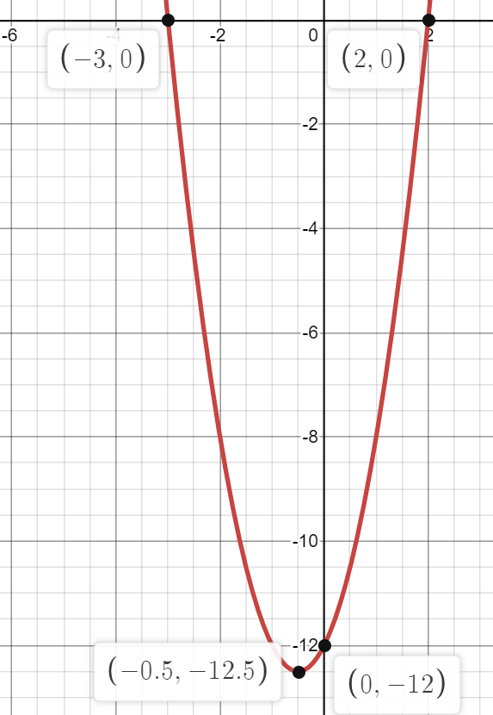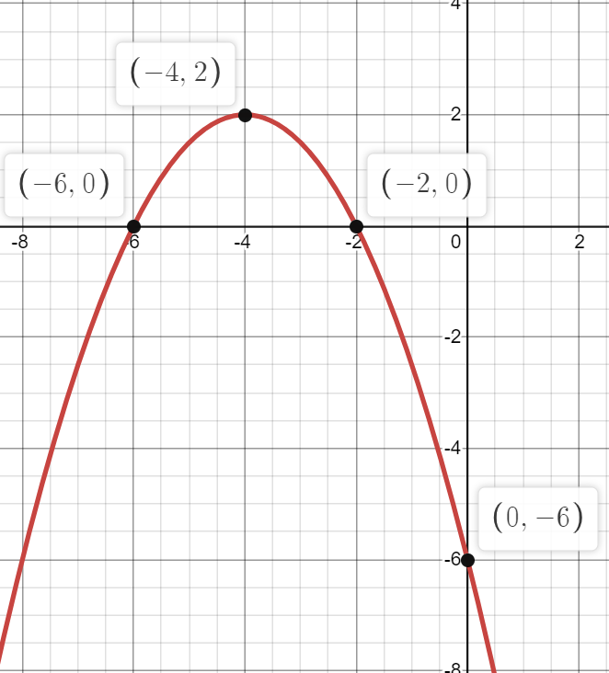

- A grasshopper jumps off a rock and his path is modeled by the equation
$$h=-2t^{2}+7t+12$$
where h is the height in centimetres and t is the time in seconds.

- How long is the grasshopper in the air?

- What is the highest point of his leap?

- How high is the rock?

- When is it 10 cm above the ground?

- A farmer wants to make a rectangular pen for his sheep. He has 60m fencing material to cover three sides with the other side being a brick wall. He wants to use the fencing material to maximize the space for his sheep. How should he choose length and width of the pen to achieve his objective?

- A kangaroo kicks a ball and it lands 20 metres from where he kicked it. If it reaches a maximum height of 7 m, write an equation to model the path of the ball.

- Anton throws a rock off a 12 m cliff. It reaches a maximum height of 20 m from the bottom of the cliff when it is 8 m from the base of the cliff. Write an equation to model the path of the rock.

How far from the base of the cliff does it land? (Hint: Use Desmos)

- Use the quadratic formula to solve the following equations:
- $2x^{2}+7x+4=0$

- $-3x^{2}-7x+25=0$

